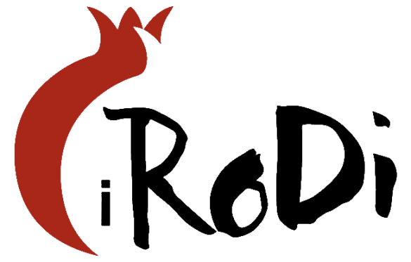

**PRESS RELEASE**

**6th International Festival «Reflection of disability in art»**

**of University of Macedonia**

**30/11-7/12/2024**

Thessaloniki, November 13th 2024

The International Festival "Reflection of disability in art" (iRoDi), as an institution of the University of Macedonia and as a unit for the Support of Social Inclusion through Art of the Laboratory of Educational and Social Inclusion of People with Learning and Adaptation Difficulties (LAESI) is organized for the 5th year from 3rd to 10th December 2023 at the University of Macedonia.

The purpose of the Festival is to support and promote the social inclusion of people with disabilities through their participation in cultural events in any role they wish, as actors, directors, volunteers or simply as spectators. The main goal of the International Festival "The reflection of disability in art" is to highlight art through the perspective of disability.

Regarding the Film Competition Section, of the 756 films of all genres, submitted via filmfreeway and by email from all over the world, 99 films were selected. Films fall within the topics: Social Support-Social Networks, Interpersonal Relationships, Dimensions of the life of the disabled, Disability: a state of being, Disability and Art, Family Relations, Disability and Sports.

The artistic schedule of the Festival includes screenings of films, Greek and foreign productions, musical performances and many more artistic actions. The festival on November 30th opens its doors with the RoDance Inclusive Dance Group and Felix Roeper, a dancer with Down Syndrome, who will come to Greece with the support of the Austrian Embassy in Athens. On 4th December at the Basketball Court of the University of Macedonia there will be a presentation of Paralympic Sports in cooperation with the Hellenic Paralympic Committee and on 5th December after the film screening in the afternoon there will be a discussion with Paralympians.

The programme of the 6th Festival has been posted on the website [here](https://rodi.uom.gr/en/archive/6th-international-reflection-of-disability-in-art-festival/program-guides). Stay tuned to the Festival's website and social media.

For more information, interested parties can contact:

University of Macedonia

156 Egnatia, P.C. 546 36, Thessaloniki

Contact phone: +302310891350

E-mail: [rod@uom.edu.gr](mailto:rod@uom.edu.gr)

Website: <http://rodi.uom.gr/>

Facebook: <https://www.facebook.com/rodifestival/>

Twitter: <https://twitter.com/rodifestival>

Instagram: <https://www.instagram.com/rodifestival/>